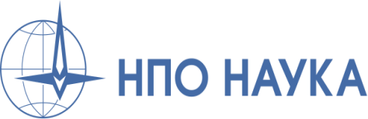
“HeliWorld” International Competition
Application Form
for Category: Innovative Project

1. | Company Name
2. | Field of business
3. | Stand No.
4. | Address, telephone, e-mail
5. | Contact person, contacts
6. | Количество публикаций. Иллюстрированность  количество публикаций/сюжетов;  - иллюстрированность;  - media outreach  - topicallity, media credibility- innovative approach  * Please send with your Application Form relevant links/  publication/video reports

Contact person: Natalia Daminова, tеl.:+7 (926) 173-60-71. Please send duly filled in Application Form before, 15, Mаy to: nm.daminova@npo-nauka.ru

