APPLICATION FORM
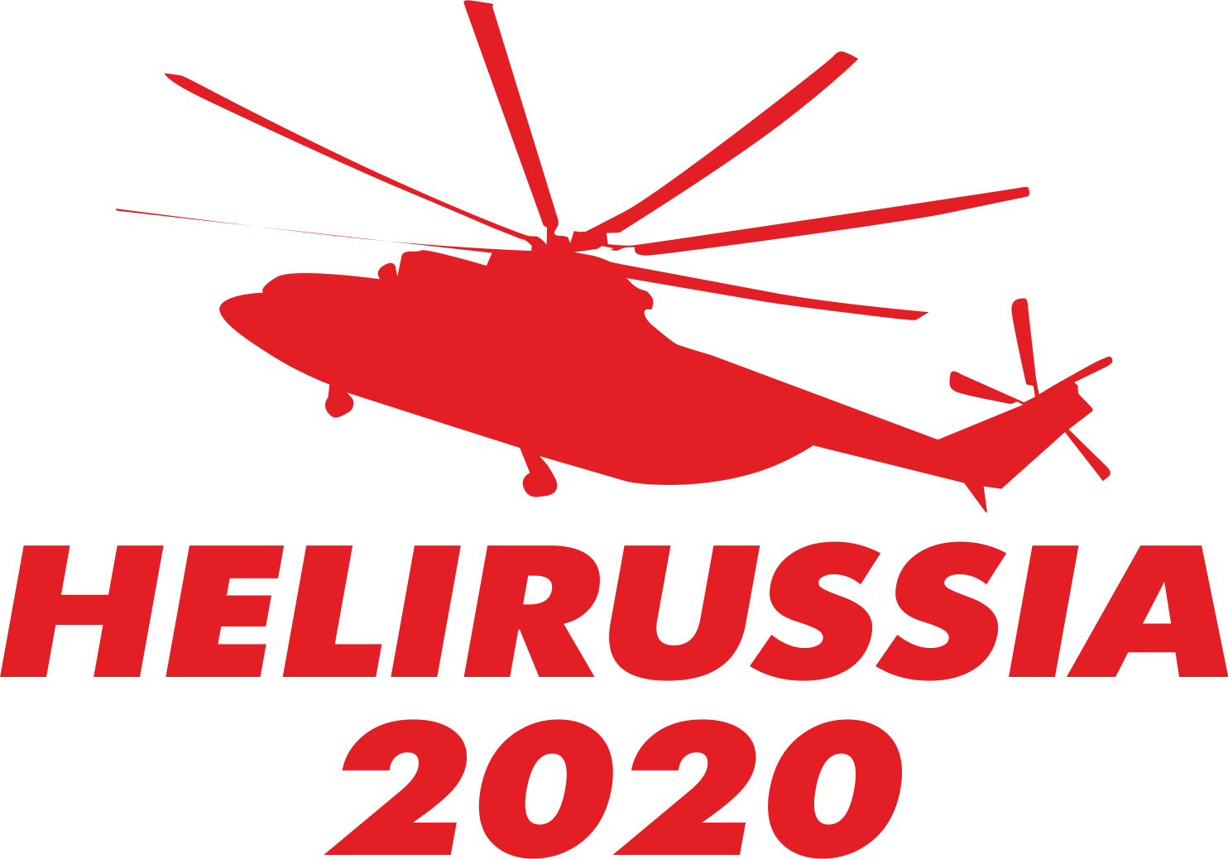
May , 2020 IEC “Crocus Expo”
Company name _____________________________________________________________________________________
Specialization ______________________________________________________________________________________
Country/Town ______________________________________________________________________________________
Address ___________________________________________________________________________________________
Tel._________________________________________ Fax ______________________________________________
E-mail_________________________________________ Website_____________________________________________
Contact person _____________________________________________________________________________________
Contact’s Position ________________________________________ Tel._______________________________________
Exhibition space | 1 sq. meter price  (EUR.) | Amount of sq.meters | Cost (EUR.)
Standard equipped booth (minimum area 9 sq. m.) | 490
Standard equipped booth in ADVANTEC design*  (minimum area 9 sq. m.) | 568
Standard equipped booth in SALERNO design*  (minimum area 9 sq. m.) | 571
Non-equipped booth (minimum area 9 sq. m.) | 460
Helicopter displaying companies:
Standard equipped booth
From 54 sq.m. to 89 sq.m. | 441
From 90 sq.m. and more | 392
Not equipped booth
From 54 sq.m. to 89 sq.m. | 414
From 90 sq.m. and more | 368
Booth position | Minimum area (sq.m.) | Extra charge, (%) | Cost (EUR.)
Linear (one exhibit side open to public) | 9 | no
Corner (two exhibit sides open to public) | 18 | 5
Peninsula (three exhibit sides open to public) | 36 | 10
Island (four exhibit sides open to public) | 54 | 15
Registration fee |  |  | 470
HeliRussia 2019 catalogue ad rates
2-nd, 3-rd cover page 3500
1/1 page, full-color 2000
1/2 page, full-color 1000
TOTAL (including all taxes)
- A payment made is considered as an acceptance of all conditions of participation in HeliRussia 2019.
- A 50% advance payment of the total application sum should be made in accordance with an Organizer’s invoice
not later than 5 banking days upon receipt thereof. The final 50% payment is to be made by April 05, 2019
in accordance with the Organizer’s invoice.
*Improved design options

SIGNATURE ____________________DATE __________________ SEAL

Please send your applications by fax: +7 (495) 477-33-18, E-mail: info@helirussia.ru

